Essay Writing: Outline

**1. Preliminary outline:**

**1.1 Decide on the purpose, central idea and main points.**

Example:

From Art of Public Speaking: Chapter 8: P167

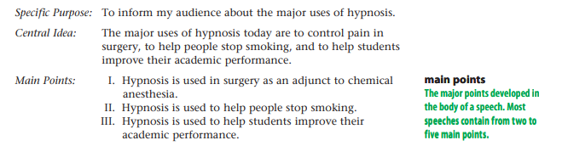

**1.2 Work on the support of the three main points in the Body section**

Example:

From Art of Public Speaking: Chapter 8: P176

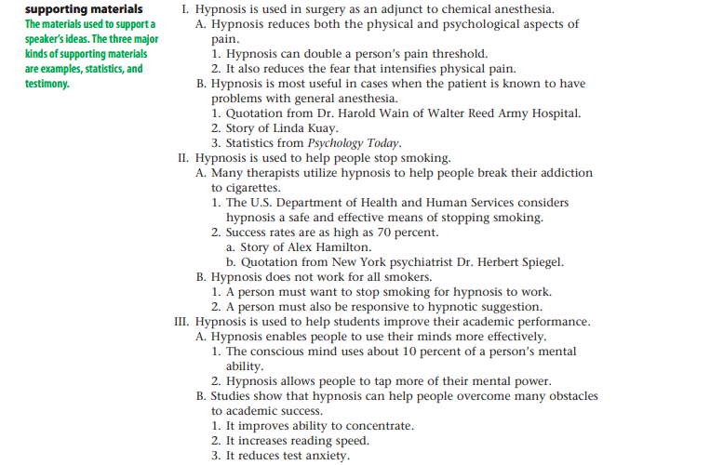

2. Final outline

Example:

**Native American Influences on Modern U.S. Culture**

I. Introduction

General statements: meeting/cultural exchange between European settlers and native Americans

[a historical story to introduce the general topic]

Thesis statement: Native Americans have made many valuable contributions to modern U.S. culture, particularly in the areas of language, art, food, and government.

II. Body

A. Topic sentence: Native Americans left a permanent mark on the English language.

1. Names of places-cities, towns, rivers, and states

a. States: Delaware, Iowa, Illinois, Alabama

b. Cities: Chicago, Miami, Spokane

2. Names of animals and plants

a. Animals: chipmunk, moose, raccoon, skunk

b. Plants: tobacco, squash

[Support: examples]

B. Topic sentence: Art is another area of important Native American contributions.

1. Navajo rugs

2. Silver and turquoise jewelry

3. Native crafts

a. Pottery

b. Leather products

c. Beadwork

[Support: examples]

C. Topic sentence: Agriculture is another area in which Native Americans had a great and lasting influence on American people.

1. Farming techniques

a. Fertilizer

b. Irrigation methods and crop rotation

2. Food

a. Corn

b. Chocolate

[Support: examples: instances]

D. Topic sentence: Citizens of the United States are also indebted to the native people for our form of government

1. Government of Iroquois-a large tribe with many branches ("nations")

a. Disputes among various branches

b. League of Iroquois formed by the five nations

a) Each nation was autonomous in running its own internal affairs

b) All the nations acted together when dealing with outsiders

2. A similar system adopted by the 13 colonies after independence

a. Each colony (future state) was autonomous in managing own affairs.

b. All the colonies would join forces to deal with matters that concerned them all.

[Support: example: problem-solution pattern]

III. Conclusion

1. summary/restatement of the thesis: ...see from these few examples the extent of Native American influence on our language, our art forms, our eating habits, and our government.

2. finishing touch: attitude: The people of the United States are deeply indebted to Native Americans for their contributions to U.S. Culture.